

Heuristic Evaluation Activity

For the assignment, I chose the website bigbasket.com. BigBasket is one of India’s largest online grocery delivery platforms. It offers a variety of categories and product types.

I applied the following heuristics:
Visibility of system status
User control and freedom
Consistency and standards
Recognition rather than recall
Flexibility and efficiency of use

I used the severity scale:
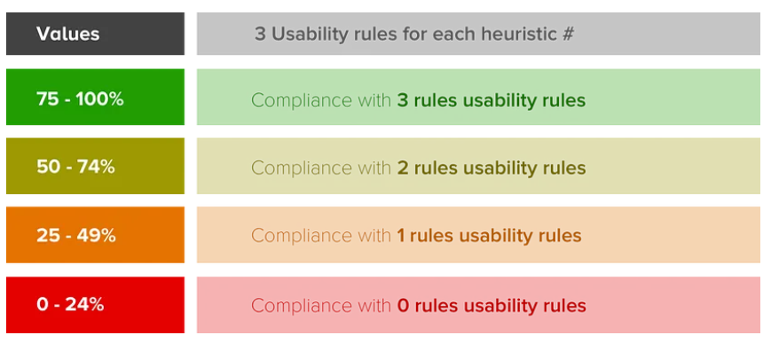

HEURISTIC #1

VISIBILITY OF SYSTEM STATUS

1.1. Is the user aware of their current position within the user journey?

The breadcrumb trail shows the user's path through a website, allowing them to quickly return to higher level pages within the site hierarchy. The checkout screen also clearly shows the user where they are in the payment process flow.

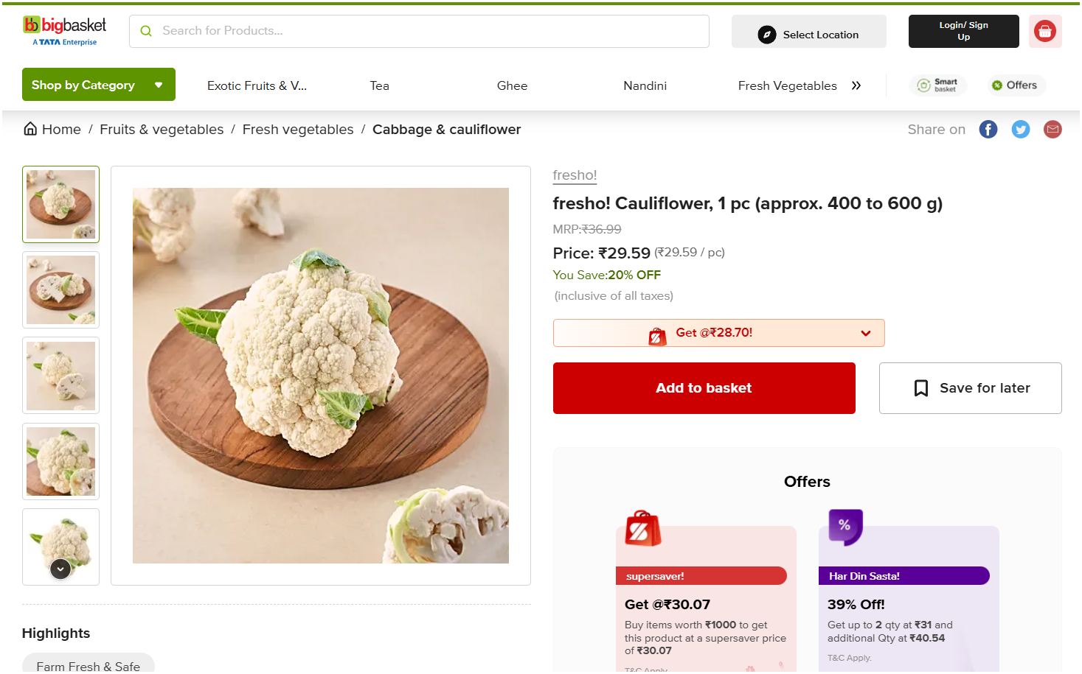

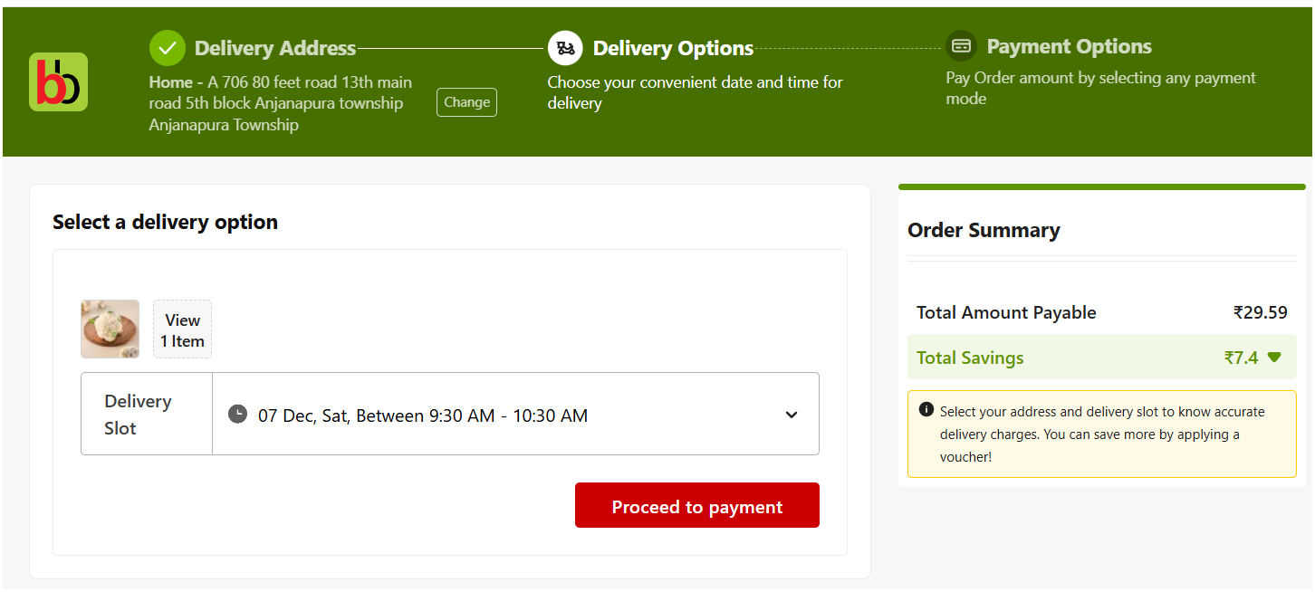

1.2. Is the user notified about changes in their user journey?

It is clearly highlighted which of the selected items are not available. This is also true when the items in the shopping cart become unavailable. Also changes in the item prices are clearly notified to the users at all places.

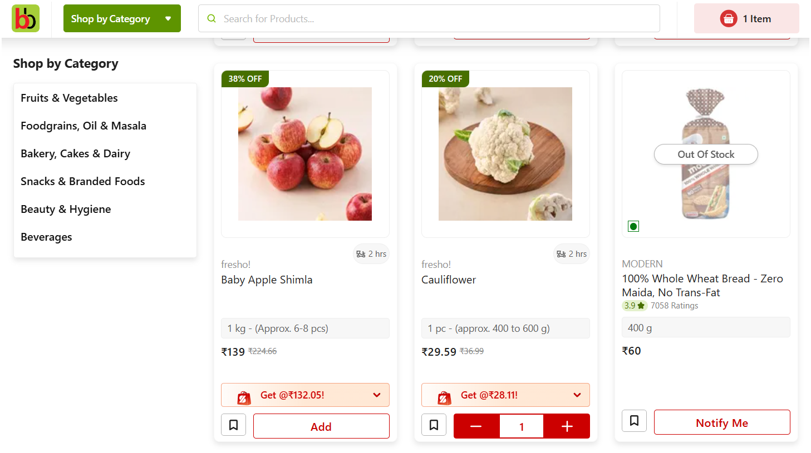

1.3. Is the user aware of factors that can have a significant impact on their experience?

It is clearly mentioned how much time it takes to deliver the product. It also shows if there is a delay in the delivery due to weather conditions on top of the page.

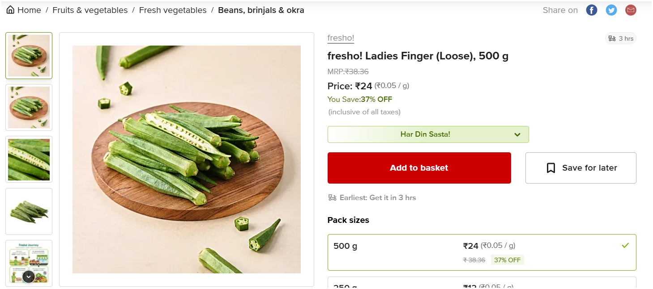

HEURISTIC #2

USER CONTROL AND FREEDOM

2.1. Is the user able to exit all states such as pop-ups and multimedia? Is the exit state consistent and clear?

The exit buttons are similar in the text boxes as well as the pop-ups and are consistent and non-confusing to the users.

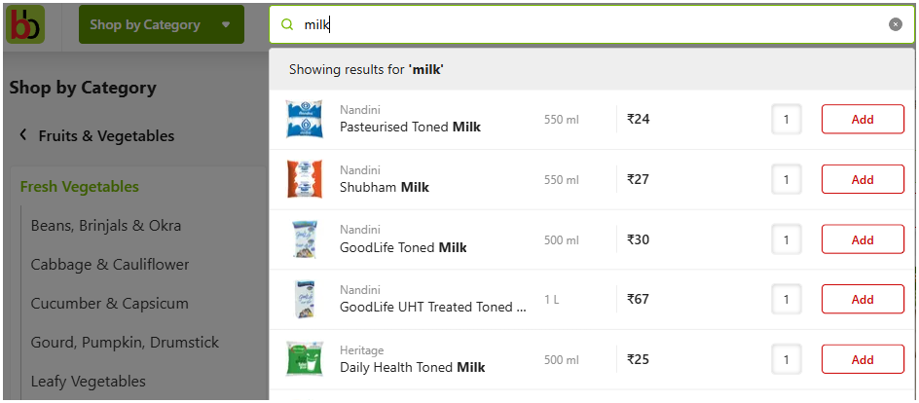

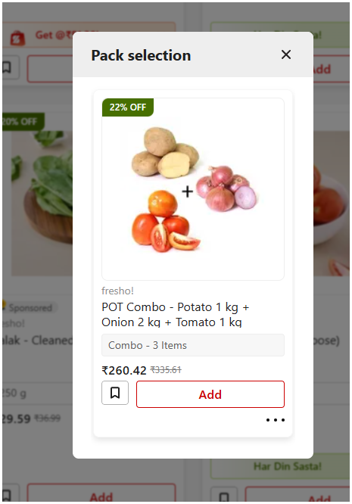

2.2. Is the user able to use the core sections of the website without signing up?

The user is able to browse all available products, add items to cart, select location and other options. The user is asked to login before viewing the cart. The user is not forced to create an account at any time during their user journey.

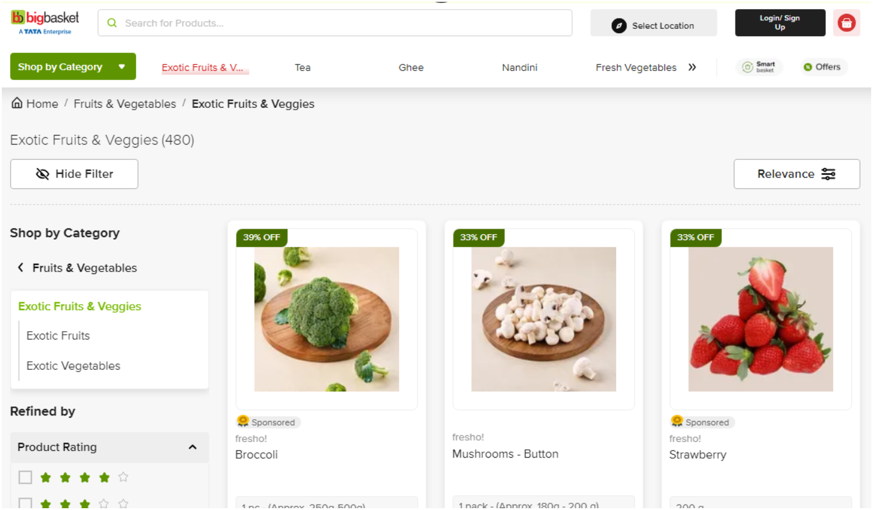

2.3. Does the user have control over their personal information?

The user can update their personal information they cannot delete their profile, thus don’t have full control over their personal information.

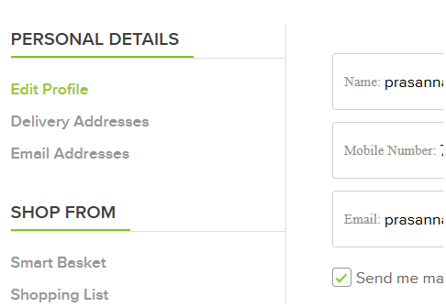

HEURISTIC #3

CONSISTENCY AND STANDARDS

3.1. Is there a consistent design standard for all call to actions (CTA) on the website?

Most of the design elements are the same in a group and sync well. But the consistency is missing across all pages. Like the Form controls in the ‘My Account’ section have different design standards and do not match to the majority design standards.

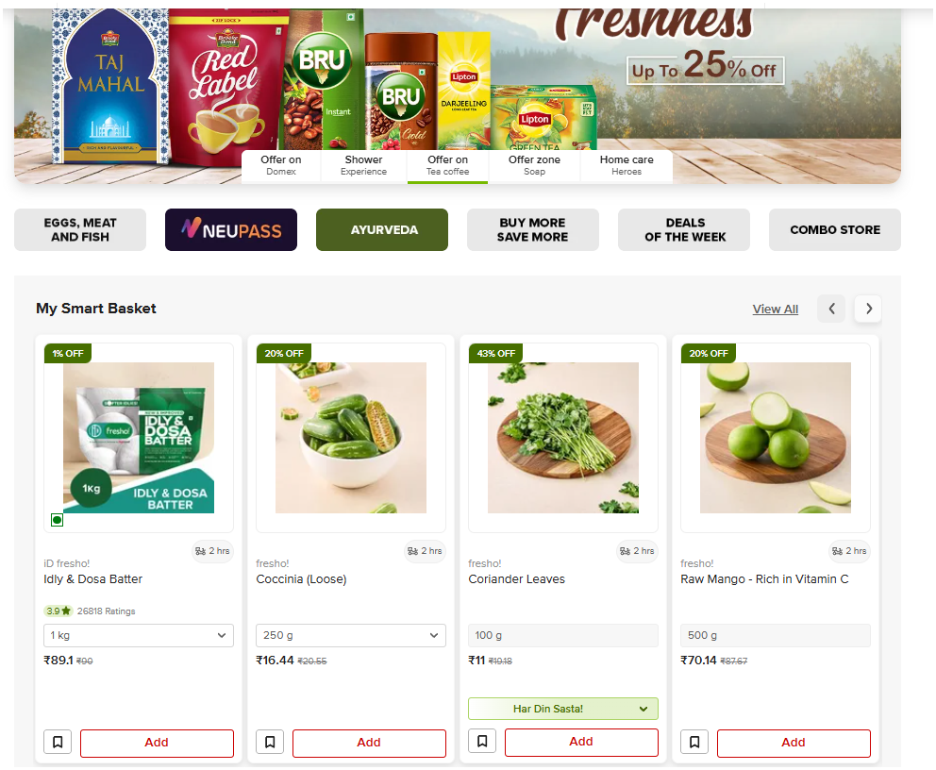

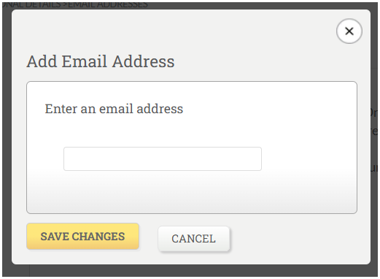

3.2. Is there a consistent design standard for form controls?

The design standard varies in the form controls. The email addresses input collection also varies from the Personal Details section. The font size and presentation for the form controls vary too. Email can be collected in the same manner as Personal Details instead of pop-up in order to stay consistent.

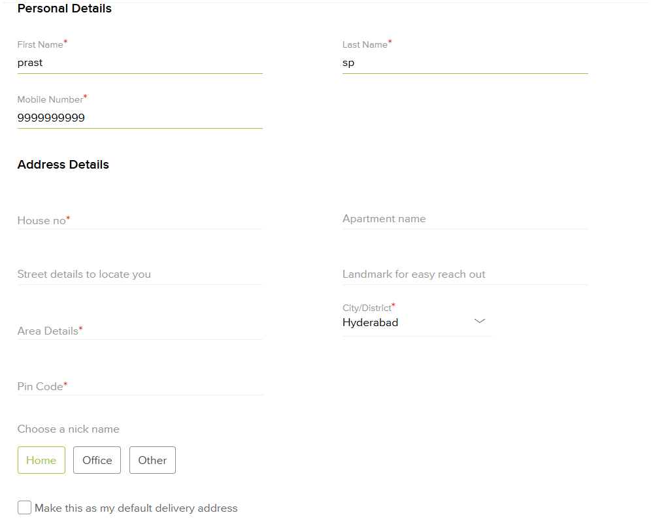




3.3. Is there a consistent design standard for headings?

All the headings and subheadings are consistent and give the necessary information in similar fashion. The user can at a glance check all the items listed under their interested section.

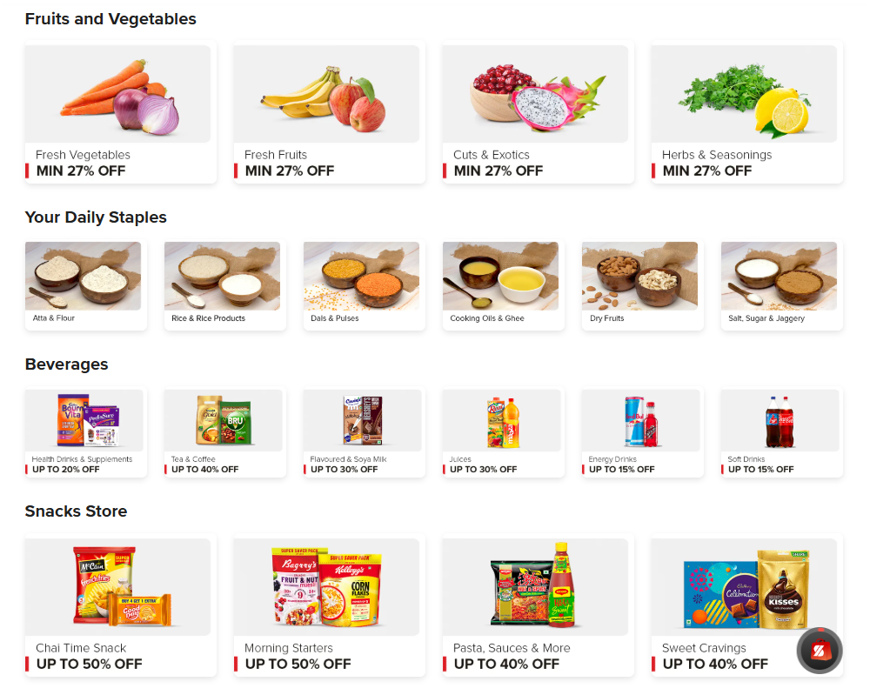

HEURISTIC #4

RECOGNITION RATHER THAN RECALL

4.1. Is the user presented with a list of recently viewed products or pages

The user has an option to view the frequently bought items from the individual item details page. There is no option to view a list of recently viewed items.

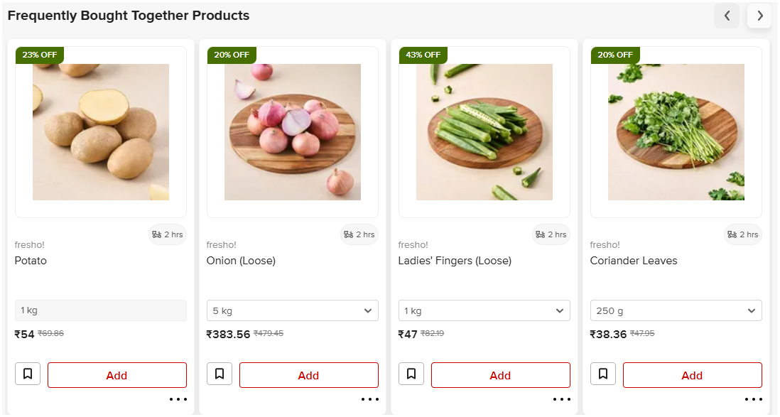

4.2. Is the user presented with customized content based on previous actions?

The user is presented with the option, My Smart Basket, to view the previously ordered items on the Home Page. This is useful to avoid searching for commonly ordered items.

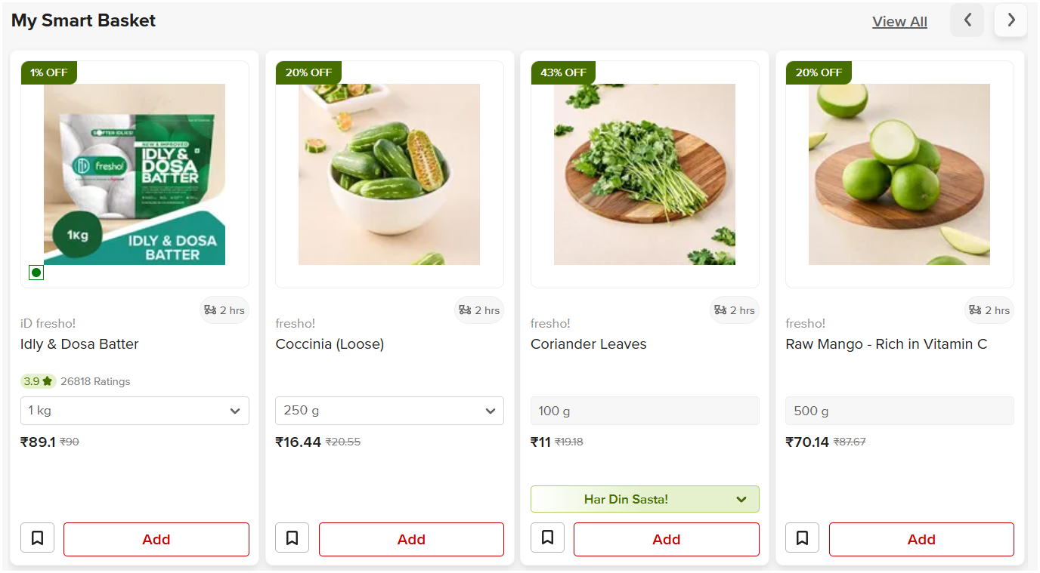

4.3. Is the user presented with navigational items that reduce cognitive load and aid recall?

The user is presented with the section Did You Forget in the View Cart page to aid recall for items the user might have forgotten to add, based on earlier orders.

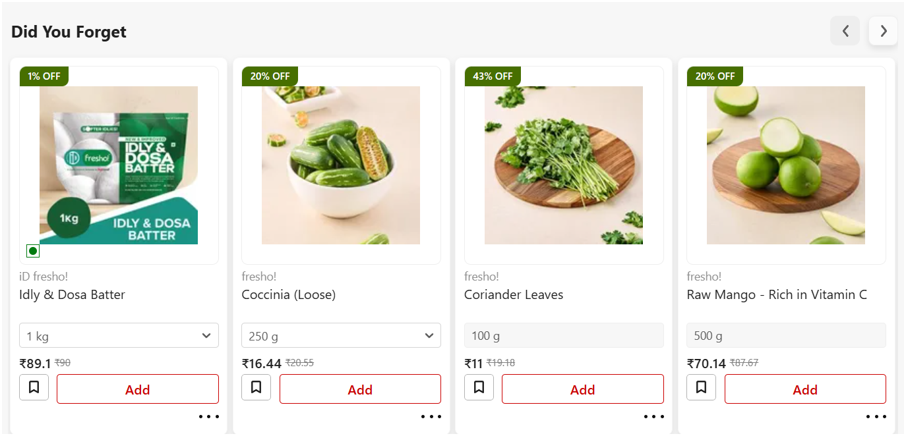

HEURISTIC #5

FLEXIBILITY AND EFFICIENCY OF USE

5.1. Is the user presented with shortcuts to end goals?

In my view, options like Tea, Fresh Vegetables, and so on in the top menu serves as shortcuts to quickly browse the items and removes the strain to type and search for a specific item every time.

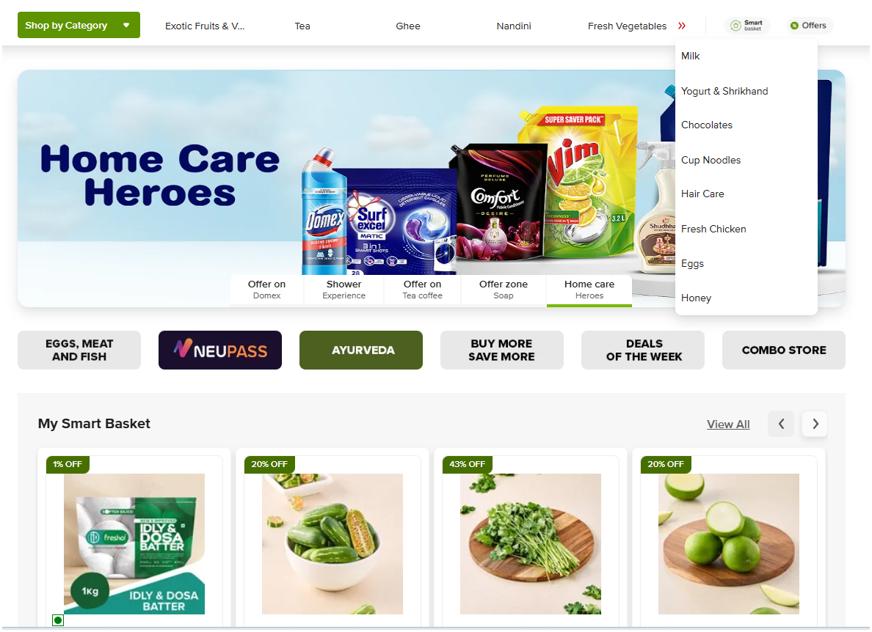

5.2. Is the user able to tailor frequent actions?
There are options under My Account section Shopping List and Past Orders. Through this, the user can add items from the previous order one by one. But there is no option to re-order all items from the list from here, which is okay because the items can be added easily with click reviewing the cost and availability.

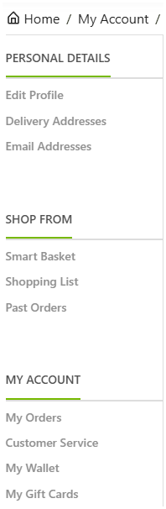

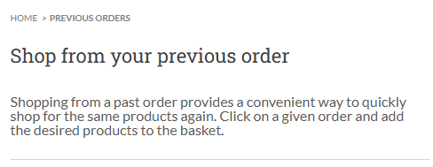

5.3. Is the user presented with ambient information for quick actions?

While the user can see which items are Out Of Stock (as mentioned above), the user cannot see badges like Only 3 left in stock!

Evaluation Criteria (3 usability rules for each heuristic) | Score | Values
Visibility of system status | 3/3 | 75 - 100 %
User control and freedom | 2/3 | 50 - 74 %
Consistency and standards | 1/3 | 25 - 49%
Recognition rather than recall | 2/3 | 50 - 74 %
Flexibility and efficiency of use | 2/3 | 50 - 74 %

